username : @i_mutamuriz

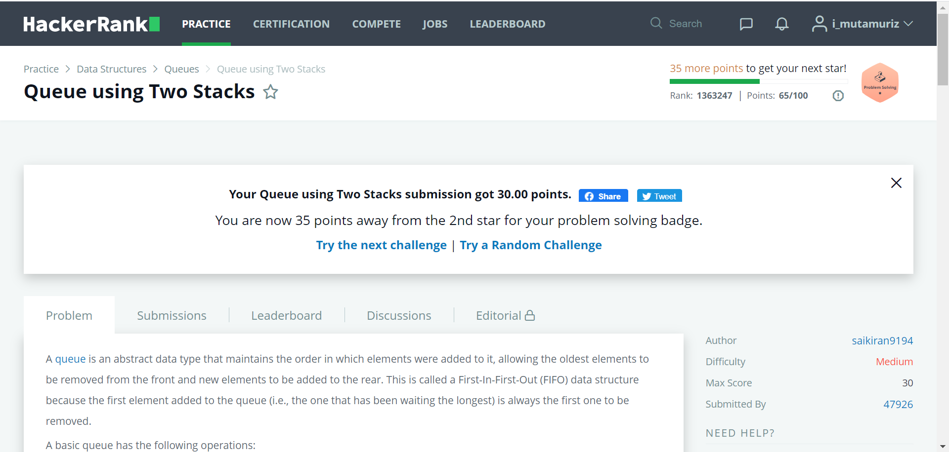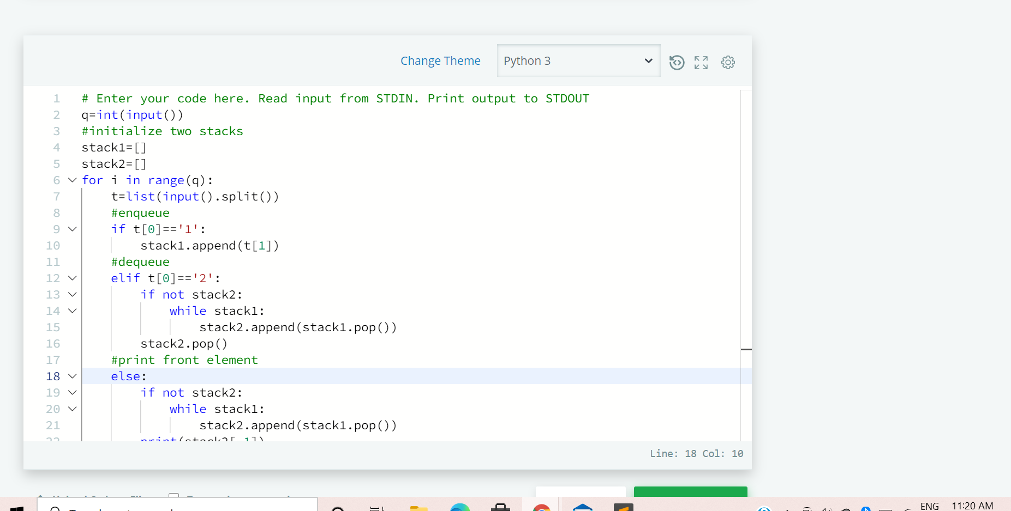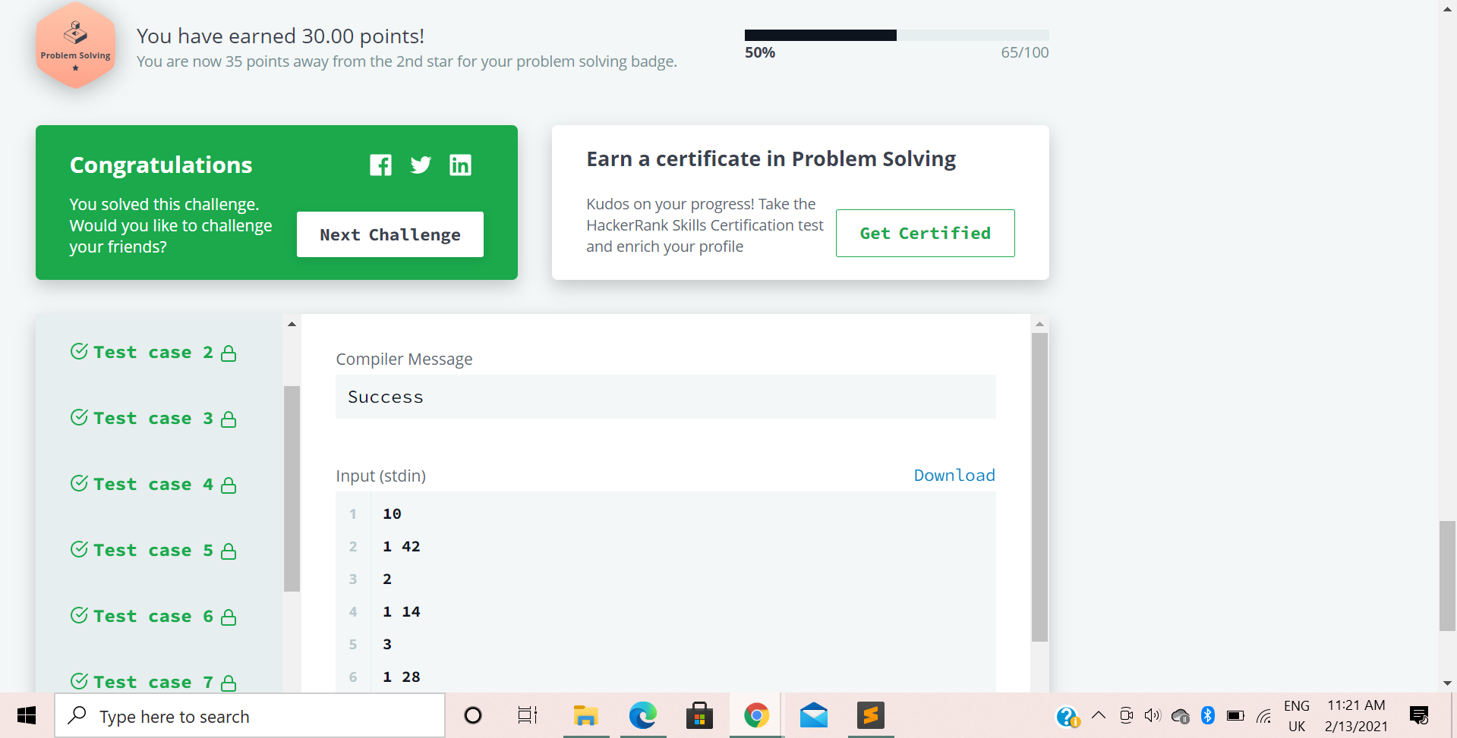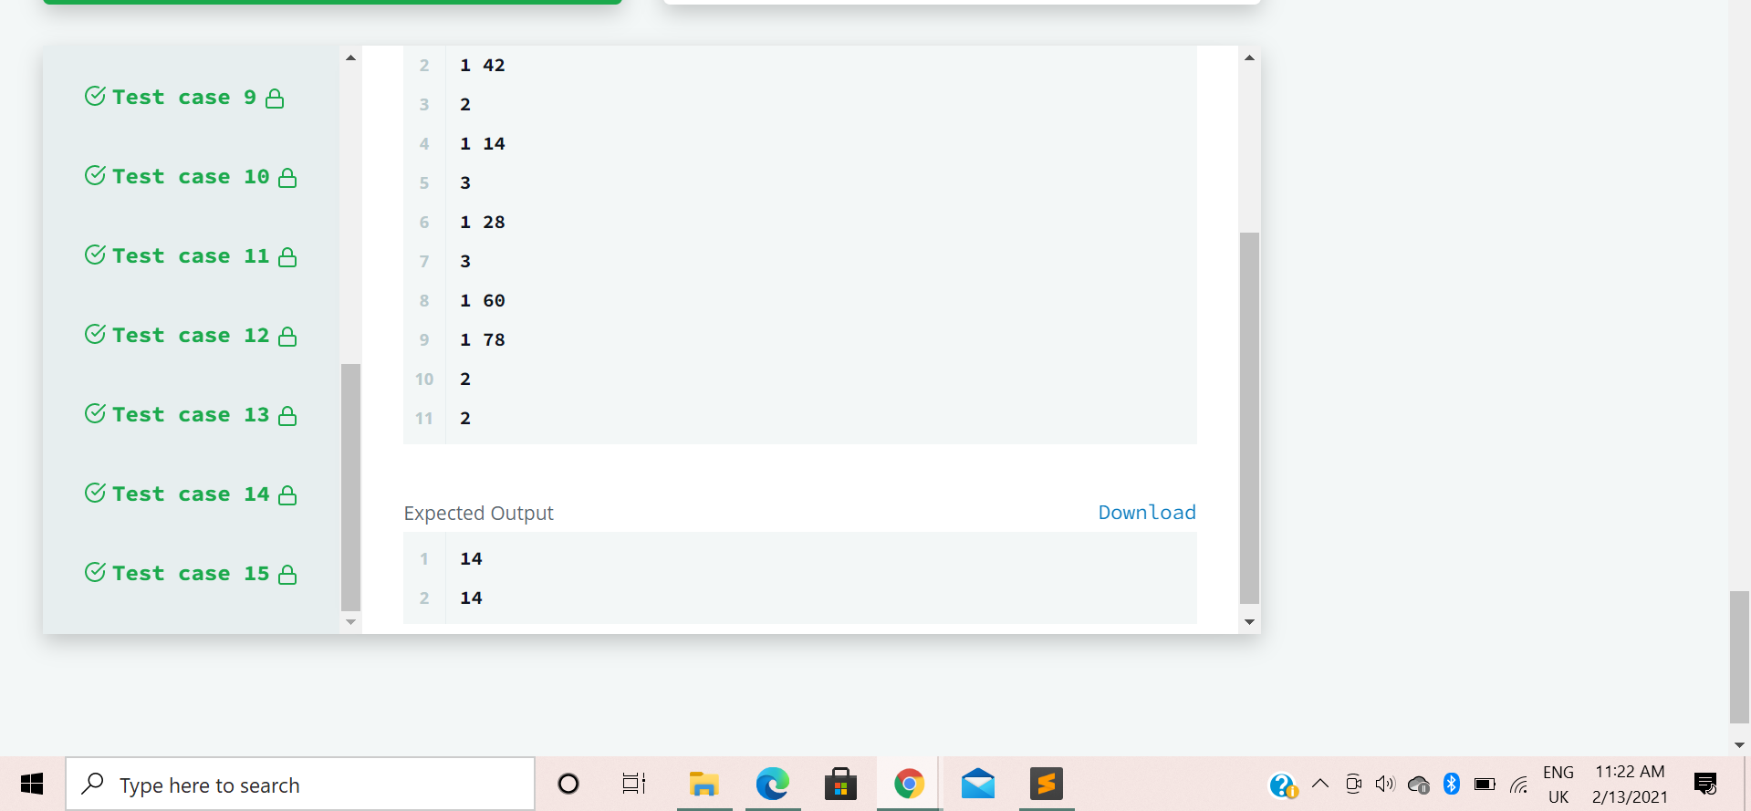

Code:

# Enter your code here. Read input from STDIN. Print output to STDOUT

q=int(input())

#initialize two stacks

stack1=[]

stack2=[]

for i in range(q):

t=list(input().split())

#enqueue

if t[0]=='1':

stack1.append(t[1])

#dequeue

elif t[0]=='2':

if not stack2:

while stack1:

stack2.append(stack1.pop())

stack2.pop()

#print front element

else:

if not stack2:

while stack1:

stack2.append(stack1.pop())

print(stack2[-1])